**Experiment-1**

Designthefollowingstaticwebpagesrequiredforanonlinebookstorewebsite. **HOMEPAGE:**

* The static home page must contain three frames.
* Top frame: Logo and the college name and links to Homepage, Login page, Registration page, Catalogue page and Cart page (the description of these pages will be given below).

For example: When you click the link “CSE” the catalogue for CSE Books should be displayed in the Right frame. Right frame: The pages to the links in the left frame must be loaded here. Initially this page contains description of the web site.

|  |  |  |  |  |
| --- | --- | --- | --- | --- |
| **Logo** |  | **Web Site Name** |  |  |
| Home | Login | Registration | Catalogue | Cart |
| CSE |  |  |  |  |
| ECE |  | Description of the | WebSite |  |
| EEE |  |  |  |  |
| CIVIL |  |  |  |  |

**Code:**

**=>index.html<=**

<html>

<head>

    <title>Shri Ram Group Of Colleges</title>

    <link rel="stylesheet" href="style.css">

</head>

<frameset cols="25%,75%">

    <frameset rows="25%,5%,70%">

        <frame name="f11" src="logo.html">

        <frame id="nav" name="f21" src="home1.html">

        <frame name="f31" src="courses1.html">

    </frameset>

    <frameset rows="25%,5%,70%">

        <frame name="f12" src="name.html"/>

        <frameset cols="25%,25%,25%,25%">

            <frame id="nav" name="f22" src="login1.html"/>

            <frame id="nav" name="f23" src="registration1.html"/>

            <frame id="nav" name="f24" src="catalog1.html"/>

            <frame id="nav" name="f25" src="cart1.html"/>

        </frameset>

        <frame style="padding-left: 20%; padding-right: 20%;" name="f32" src="main.html"/>

    </frameset>

</frameset>

</html>

**=>main.html<=**

<!DOCTYPE html>

<html>

<head>

    <title>Main Content</title>

</head>

<body>

    <h1>Welcome to the Online Bookstore</h1>

    <p>This website allows you to browse books, add them to your cart, and purchase them online. Use the menu on the left to navigate through the different pages of the site.</p>

    <ul>

        <li>Explore our <b>Catalogue</b> for the latest books in various categories.</li>

        <li>Login to manage your account and orders.</li>

        <li>Register if you are a new user to enjoy our services.</li>

    </ul>

    <p>Enjoy your shopping!</p>

</body>

</html>

**=>name.html<=**

<html>

<head>

    <title>HOME</title>

</head>

<body bgcolor="yellow">

    <div align="center" style="font-size:40pt;color:red;padding-top: 10px;"><b>Shri Ram Group Of Colleges,Muzaffarnagar</b></div>

</body>

</html>

**=>logo.html<=**

<html>

<head>

    <title>LOGO</title>

</head>

<body>

    <img src="logo.png" height="100%" width="100%">

</body>

</html>

**=>home1.html<=**

<html>

<head>

    <title>Home</title>

    <link rel="stylesheet" href="style.css">

</head>

<body>

    <a href="main.html" target="f32">HOME</a>

</body>

</html>

**=>cart1.html<=**

<html>

<head>

    <title>CART</title>

    <link rel="stylesheet" href="style.css">

</head>

<body>

    <a href="cart.html" target="f32">CART</a>

</body>

</html>

**=>registration1.html<=**

<html>

<head>

    <title>REGISTRATION</title>

    <link rel="stylesheet" href="style.css">

</head>

<body>

    <a href="registration.html" target="f32">REGISTRATION</a>

</body>

</html>

**=>catalog1.html<=**

<html>

<head>

    <title>CATALOGUE</title>

    <link rel="stylesheet" href="style.css">

</head>

<body>

    <a href="catalog.html" target="f32">Catalogue</a>

</body>

</html>

**=>login1.html<=**

<html>

<head>

    <title>LOGIN</title>

    <link rel="stylesheet" href="style.css">

</head>

<body>

    <a href="login.html" target="f32">LOGIN</a>

</body>

</html>

**=>courses1.html<=**

<html>

<head>

    <title>COURSES</title>

    <link rel="stylesheet" href="style.css">

</head>

<body>

    <ul type="none">

         <li><a href="CSE.html" target="f32">CSE</a><br><br></li>

         <li><a href="ECE.html" target="f32">ECE</a><br><br></li>

         <li><a href="EEE.html" target="f32">EEE</a><br><br></li>

         <li><a href="CIVIL.html" target="f32">CIVIL</a><br><br></li>

    </ul>

</body>

</html>

**=>CSE.html<=**

<html>

<head>

    <title>CSE</title>

</head>

<body>

    <h1><div align = "Center">Department of Computer Science & Engineering </div></h1>

    <p align="justify">

        The Department of Computer Science & Engineering, established in the year 2002 with current

        intake of 240 students,

        imparts quality education and believes in creating new opportunities for students to meet the

        challenges of technologicaldevelopment in Computer Science & Engineering. The B. Tech. (CSE) program is

        affiliated with

        Dr. APJ Abdul Kalam Technical University, Lucknow, and is approved by AICTE, New Delhi.

        The department has qualified faculty members, infrastructure, and state-of-the-art equipment which

        help

        in providing an excellent environment for teaching and learning. The department is actively

        involved in

        Industrial Training, Project Development and other professional activities. Department of Computer

        Science

        and Engineering has signed various MOUs with highly recognized organizations to provide live

        projects and

        Internship opportunities to our Engineering Students. Industrial visits, Workshops, Seminars,

        Conferences,

        and Mini Projects for students are also conducted regularly to encourage students. The major

        employers of

        our students are well-renowned Indian conglomerates like TCS, Infosys, Wipro, HCL, and other

        multinational

        companies including IBM, Accenture & HP.

    </p>

</body>

</html>

**=>EEE.html<=**

<html>

<head>

    <title>EEE</title>

</head>

<body>

    <h1><div align = "Center">Department of Electrical and Electronics Engineering</div></h1>

    <p align="justify">

        The Department of Electrical and Electronics Engineering was established in year 2004 with

        aim to prepare students for a successful professional career in respective field. Historically,

        the field of Electrical & Electronics Engineering is one of the most versatile and has broad

        applications in multidisciplinary sectors. The Department has focused towards integrating

        academicswith cutting edge technologies in modern world.

    </p>

</body>

</html>

**=>ECE.html<=**

<html>

<head>

    <title>ECE</title>

</head>

<body>

    <h1><div align = "Center">Electronics and Communications Engineering</div></h1>

    <p align="justify">

        Electronics and Communications Engineering (ECE) involves researching, designing,

        developing and testing of electronic equipment used in various systems. Electronics and

        Communications engineers also conceptualize and oversee the manufacturing of communications

        and broadcast systems. This stream of engineering deals with analog transmission, basic electronics,

        microprocessors, solid state devices, digital & analog communication, analogintegrated circuits,

        microwave engineering, satellite communication, antenna and wave propagation. It also deals with

        the manufacturing of electronic devices, circuits, and communications equipment. This branch of

        engineering also plays a vital role ensuring fastest means of communication across the world.

    </p>

</body>

</html>

**=>CIVIL.html<=**

<html>

<head>

    <title>CIVIL</title>

</head>

<body>

    <h1><div align = "Center">Department of Civil Engineering</div></h1>

    <p align="justify">

        Civil engineering is the professional practice of designing and developing

        infrastructure projects. This can be on a huge scale, such as the development

        of nationwide transport systems or water supply networks, or on a smaller scale,

        such as the development of individual roads or buildings.

    </p>

</body>

</html>

**=>style.css <=**

a {

    text-decoration: none;

    color: "#000000";

}

a:hover {

    color:#00A0C6;

    text-decoration:none;

    cursor:pointer;

}

#nav {

    padding-left : 6rem;

}

**Preview{Experiment-1}:** 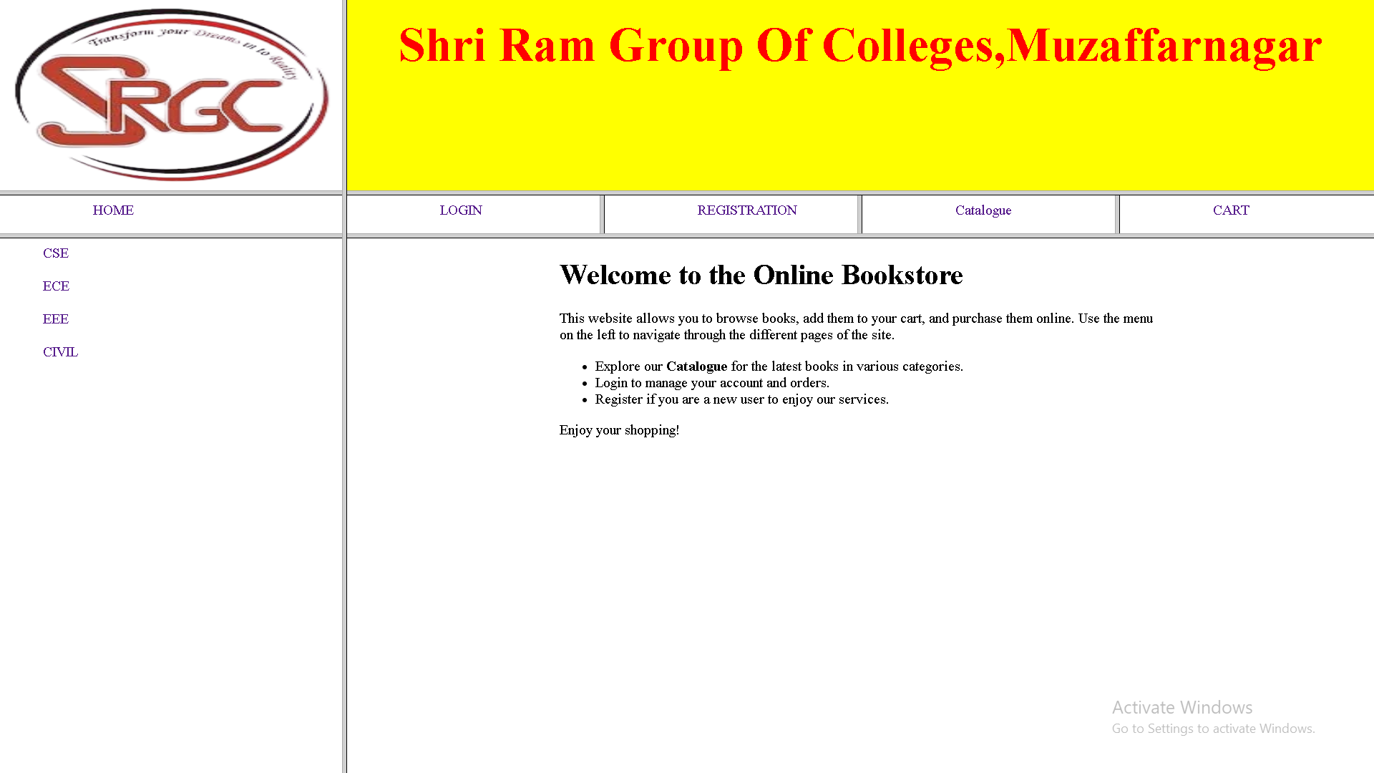

**Experiment-2**

**LOGINPAGE:** This page looks like below:

|  |  |  |  |  |
| --- | --- | --- | --- | --- |
| **Logo** |  | **Web Site Name** |  |  |
| Home | Login | Registration | Catalogue | Cart |
| CSE |  | Login Page |  |  |
| ECE |  | User Name |  |  |
| EEE |  | Password |  |  |
| CIVIL |  | Submit | Reset |  |

**Code:**

**=>login.html<=**

<!DOCTYPE html>

<html>

<head>

    <title>LOGIN</title>

</head>

<body>

    <h1>Login Page</h1>

    <form>

        <label for="username">Username:</label>

        <input type="text" id="username" name="username"><br><br>

        <label for="password">Password:</label>

        <input type="password" id="password" name="password"><br><br>

        <button type="submit">Login</button>

    </form>

</body>

</html>

**Preview{Experiment-2}:**

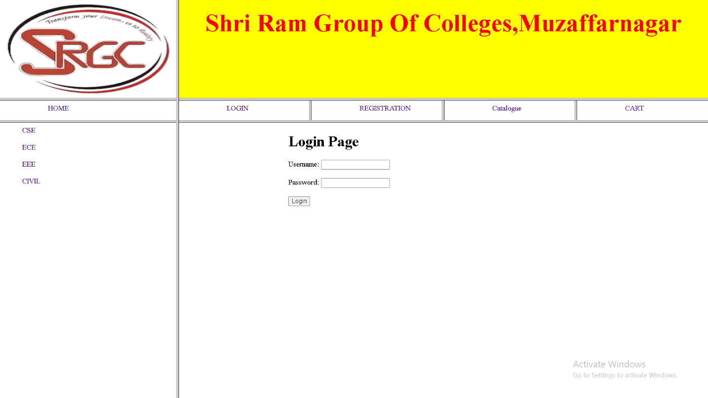

**Experiment-3**

**LOGINPAGE:** This page looks like below:

|  |  |  |  |  |
| --- | --- | --- | --- | --- |
| **Logo** |  | **Web Site Name** |  |  |
| Home | Login | Registration | Catalogue | Cart |
| CSE |  | Book:XMLBible  Author : Winston Publication:Wiely | $40.5 |  |
| ECE |  | Book :AI  Author:S.Russel Publication:Princetonhall | $63 |  |
| EEE |  | Book : Java 2 Author:Watson Publication:BPBpublications | $35.5 |  |
| CIVIL |  | Book : HTML in 24 hours Author : Sam Peter Publication:Sampublication | $50 |  |

**Code:**

**=>catalog.html<=**

<!DOCTYPE html>

<html>

<head>

    <title>Catalogue</title>

</head>

<body>

    <h1>Book Catalogue</h1>

    <table border="1" style="  border: 1px solid black;border-collapse: collapse;">

        <tr>

            <th>Book</th>

            <th>Author</th>

            <th>Publisher</th>

            <th>Price</th>

            <th>Add to Cart</th>

        </tr>

        <tr>

            <td>

                <img src="book1.jpg" alt="Book 1" width="150">

                <br>

                Engineering Physics

                </td>

            <td>Winston</td>

            <td>Wiley</td>

            <td>$40.5</td>

            <td><button>Add to Cart</button></td>

        </tr>

        <tr>

            <td><img src="book2.jpg" alt="Book 1" width="150">

                <br>

                computer Organization and Architecture</td>

            <td>Winston</td>

            <td>Wiley</td>

            <td>$40.5</td>

            <td><button>Add to Cart</button></td>

        </tr>

        <tr>

            <td><img src="book3.jpg" alt="Book 1" width="150">

                <br>

                Engineering Physics</td>

            <td>Winston</td>

            <td>Wiley</td>

            <td>$40.5</td>

            <td><button>Add to Cart</button></td>

        </tr>

    </table>

</body>

</html>

**Preview{Experiment-3}:**

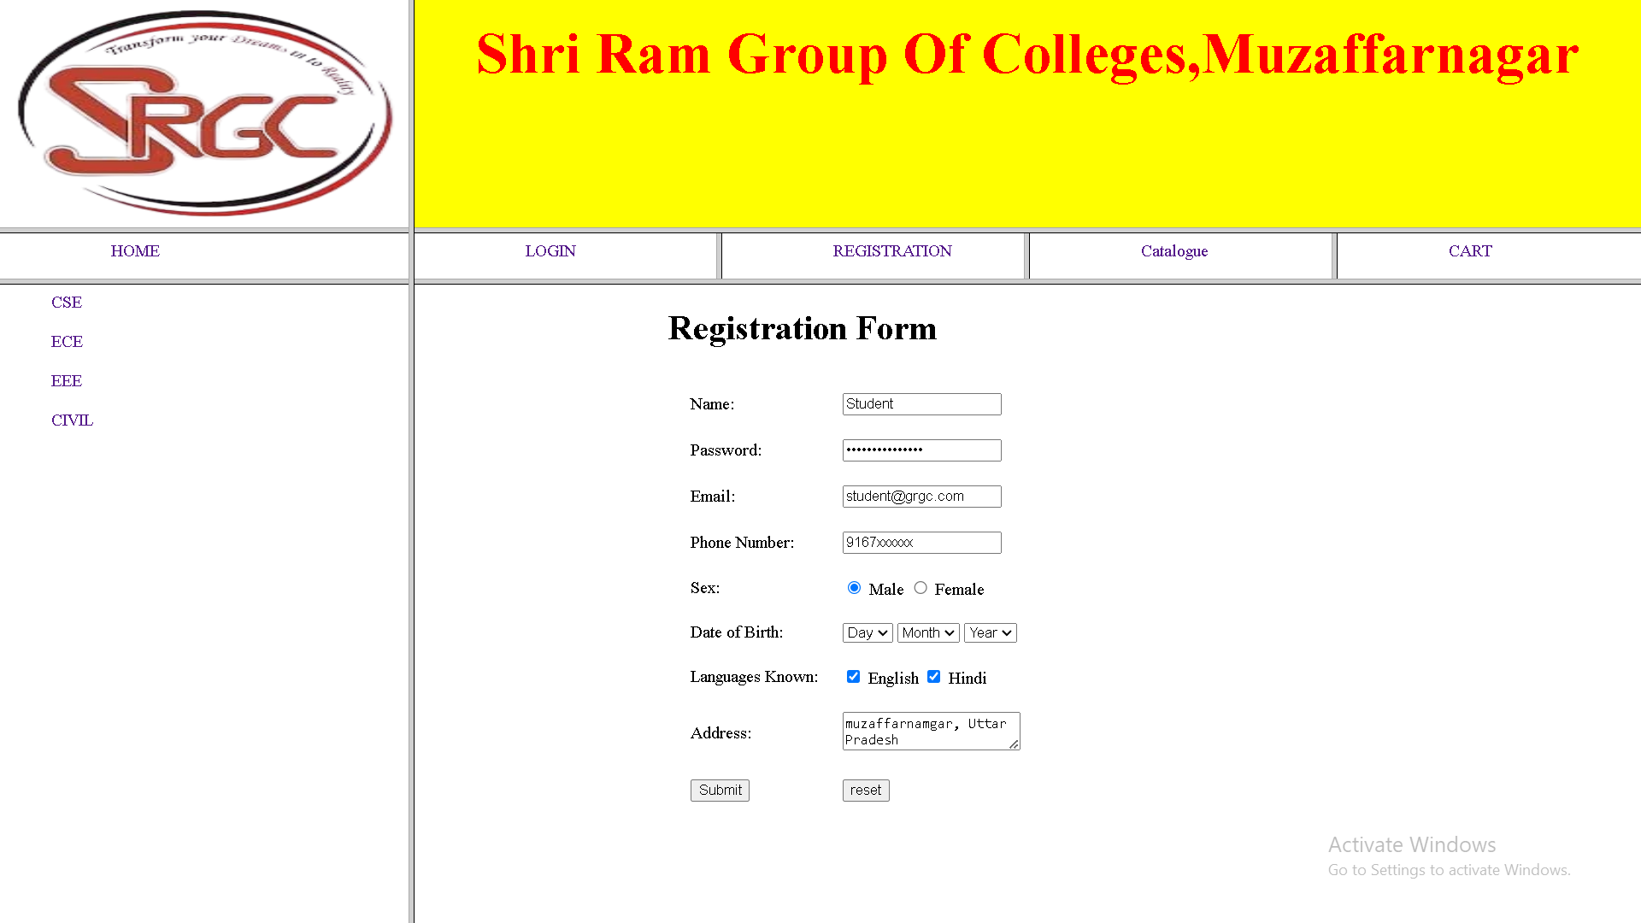

**Experiment-4**

**CARTPAGE:** The cart page contains the details about the books which are added to the cart. The cart page should look like this:

|  |  |  |  |  |
| --- | --- | --- | --- | --- |
| **Logo** |  | **Web Site Name** |  |  |
| Home | Login | Registration | Catalogue | Cart |
| CSE | Book name | Price | Quantity | Amount |
| ECE | Java 2 | $35.5 | 2 | $71 |
| EEE | XML bible | $40.5 | 1 | $40.5 |
| CIVIL | Total Amount | $130.5 |  |  |

**Code:**

**=>cart.html<=**

<!DOCTYPE html>

<html>

<head>

    <title>Cart</title>

</head>

<body>

    <h1>Your Cart</h1>

    <table border="1" style="border: 1px solid black;border-collapse: collapse;">

        <tr>

            <th>Book</th>

            <th>Quantity</th>

            <th>Price</th>

        </tr>

        <tr>

            <td>Engineering Physics</td>

            <td>1</td>

            <td>$40.5</td>

        </tr>

        <tr>

            <td>XML Bible</td>

            <td>2</td>

            <td>$40.5</td>

        </tr>

        <tr>

            <td>Engineering Physics</td>

            <td>3</td>

            <td>$40.5</td>

        </tr>

    </table>

</body>

</html>

**Preview{Experiment-4}:**

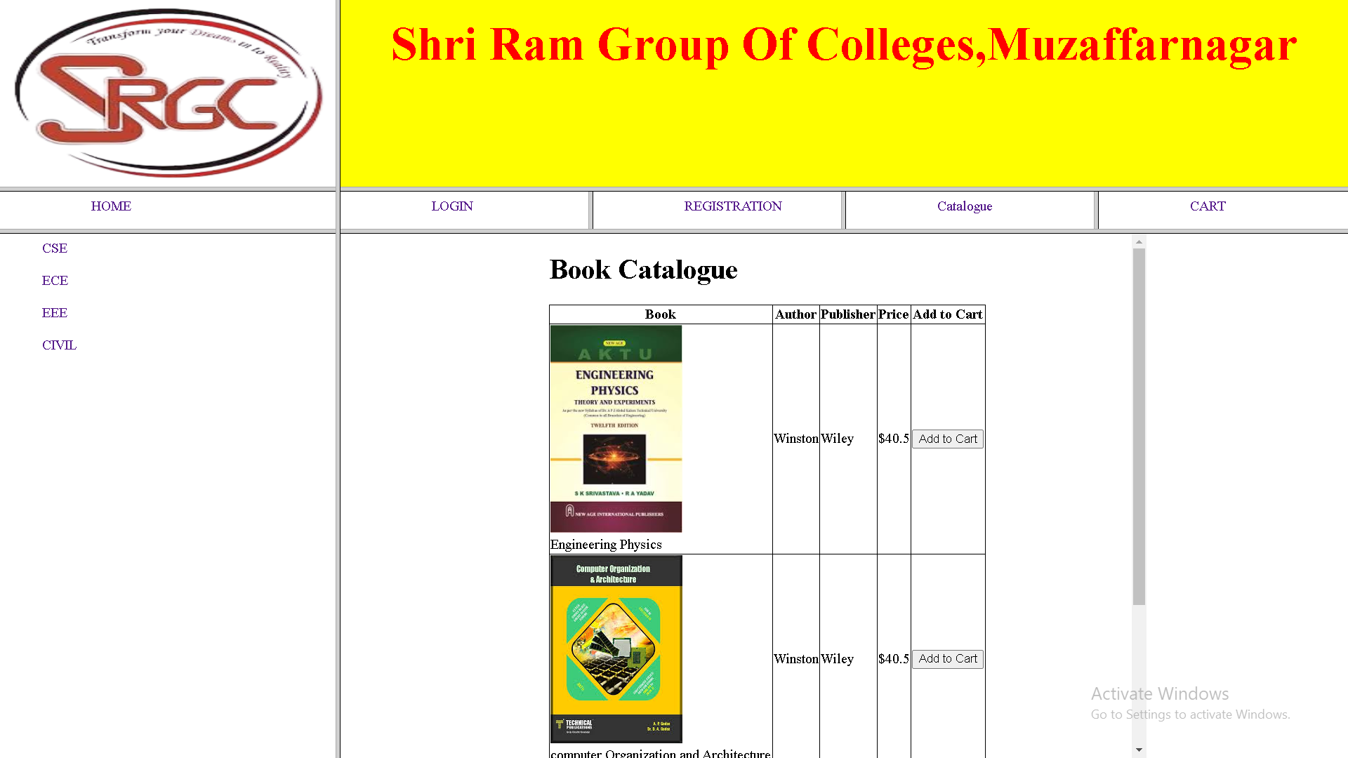

**Experiment-5**

**REGISTRATION PAGE** : Create a“ registration form“ with the following fields

1. Name (Text field)
2. Password (password field)
3. E-mailid(text field)
4. Phone Number(text field)
5. Sex(radio button)
6. Date of birth(3 select boxes)
7. Languages known(checkboxes–English, Telugu, Hindi, Tamil)
8. Address(text area)

**Code:**

**=>registration.html<=**

<!DOCTYPE html>

<html>

<head>

    <title>Registration Page</title>

    <!-- <script src="validation.js" defer></script>  -->

    <script src="validation1.js" defer></script>

</head>

<body>

    <h1>Registration Form</h1>

    <form id="registrationForm">

        <table cellspacing="20">

            <tr>

                <td>Name:</td>

                <td>

                    <input type="text" id="name" name="name">

                </td>

            </tr>

            <tr>

                <td>Password: </td>

                <td>

                    <input type="password" id="password" name="password">

                    <br>

                    <span id="passwordError" style="color: red;"></span>

                </td>

            </tr>

            <tr>

                <td>Email:  </td>

                <td>

                    <input type="text" name="email">

                </td>

            </tr>

            <tr>

                <td> Phone Number: </td>

                <td>

                    <input type="text" name="phone">

                </td>

            </tr>

            <tr>

                <td> Sex: </td>

                <td>

                    <input type="radio" name="sex" value="male"> Male

                    <input type="radio" name="sex" value="female"> Female

                </td>

            </tr>

            <tr>

                <td>Date of Birth: </td>

                <td>

                    <select name="day"><option>Day</option></select>

                    <select name="month"><option>Month</option></select>

                    <select name="year"><option>Year</option></select>

                </td>

            </tr>

            <tr>

                <td> Languages Known: </td>

                <td>

                    <input type="checkbox" name="lang" value="English"> English

                    <input type="checkbox" name="lang" value="Hindi"> Hindi

                </td>

            </tr>

            <tr>

                <td> Address: </td>

                <td>

                    <textarea name="address"></textarea>

                </td>

            </tr>

            <tr>

                <td>

                    <button type="submit">Submit</button>

                </td>

                <td>

                    <button type="reset">reset</button>

                </td>

            </tr>

        </table>

    </form>

</body>

</html>

**Preview{Experiment-5}:**

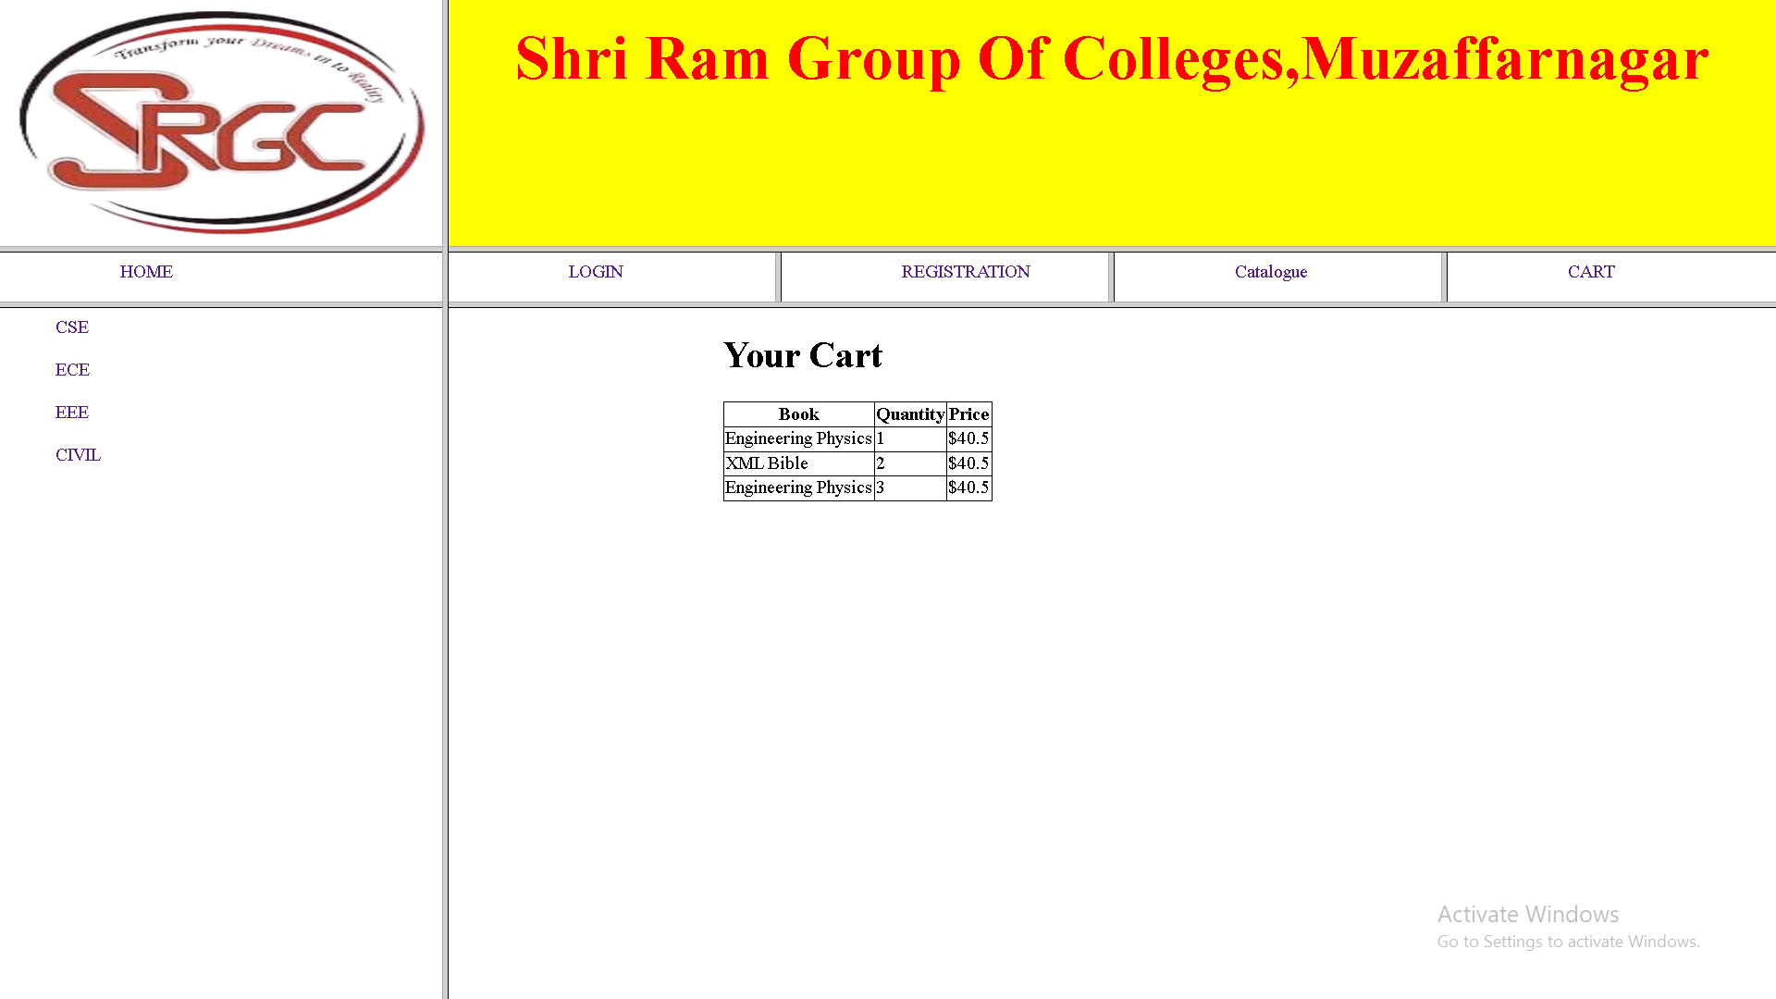

**Experiment-6**

**Js VALIDATION:** Write **JavaScript to validate** the following fields of the above registration page.

1. Name (Name should contains alphabets and the length should not be less than 6 characters).
2. Password (Password should not be less than 6 characters length).

**Code:**

**=>validation.js <=**

document.getElementById('registrationForm').addEventListener('submit', function (e) {

    e.preventDefault();

    const name = document.getElementById('name').value.trim();

    const password = document.getElementById('password').value.trim();

    const nameError = document.createElement('span');

    const passwordError = document.getElementById('passwordError');

    if (!document.getElementById('nameError')) {

        const nameInput = document.getElementById('name');

        nameInput.insertAdjacentElement('afterend', nameError);

        nameError.id = 'nameError';

        nameError.style.color = 'red';

    }

    nameError.textContent = '';

    passwordError.textContent = '';

    let isValid = true;

    if (name.length < 6 || !/^[a-zA-Z]+$/.test(name)) {

        nameError.textContent = 'Name must contain only alphabets and be at least 6 characters long.';

        isValid = false;

    }

    if (password.length < 6) {

        passwordError.textContent = 'Password must be at least 6 characters long.';

        isValid = false;

    }

    if (isValid) {

        alert('Registration successful!');

    }

});

**Preview{Experiment-6}:**

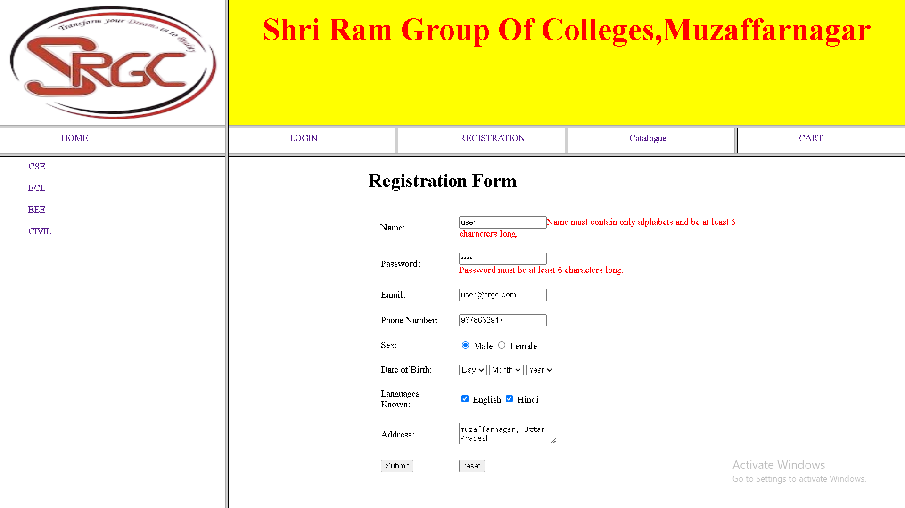

**Experiment-7**

**Js VALIDATION:**

1. E-mailid (should not contain any invalid and must follow the standard pattern([name@domain.com](mailto:name@domain.com))
2. Phone Number(Phone number should contain 10 digits only).

**Code:**

**=>validation.js<=**

document.getElementById('registrationForm').addEventListener('submit', function (e) {

    e.preventDefault();

    const name = document.getElementById('name').value.trim();

    const password = document.getElementById('password').value.trim();

    const email = document.querySelector('input[name="email"]').value.trim();

    const phone = document.querySelector('input[name="phone"]').value.trim();

    const nameError = document.getElementById('nameError') || createErrorSpan('nameError', document.getElementById('name'));

    const passwordError = document.getElementById('passwordError');

    const emailError = document.getElementById('emailError') || createErrorSpan('emailError', document.querySelector('input[name="email"]'));

    const phoneError = document.getElementById('phoneError') || createErrorSpan('phoneError', document.querySelector('input[name="phone"]'));

    nameError.textContent = '';

    passwordError.textContent = '';

    emailError.textContent = '';

    phoneError.textContent = '';

    let isValid = true;

    if (name.length < 6 || !/^[a-zA-Z]+$/.test(name)) {

        nameError.textContent = 'Name must contain only alphabets and be at least 6 characters long.';

        isValid = false;

    }

    if (password.length < 6) {

        passwordError.textContent = 'Password must be at least 6 characters long.';

        isValid = false;

    }

    const emailRegex = /^[^\s@]+@[^\s@]+\.[^\s@]+$/;

    if (!emailRegex.test(email)) {

        emailError.textContent = 'Invalid email address. Please follow the format name@domain.com.';

        isValid = false;

    }

    const phoneRegex = /^\d{10}$/;

    if (!phoneRegex.test(phone)) {

        phoneError.textContent = 'Phone number must contain exactly 10 digits.';

        isValid = false;

    }

    if (isValid) {

        alert('Registration successful!');

    }

});

function createErrorSpan(id, referenceElement) {

    const span = document.createElement('span');

    span.id = id;

    span.style.color = 'red';

    referenceElement.insertAdjacentElement('afterend', span);

    return span;

}

**Preview{Experiment-7}:**

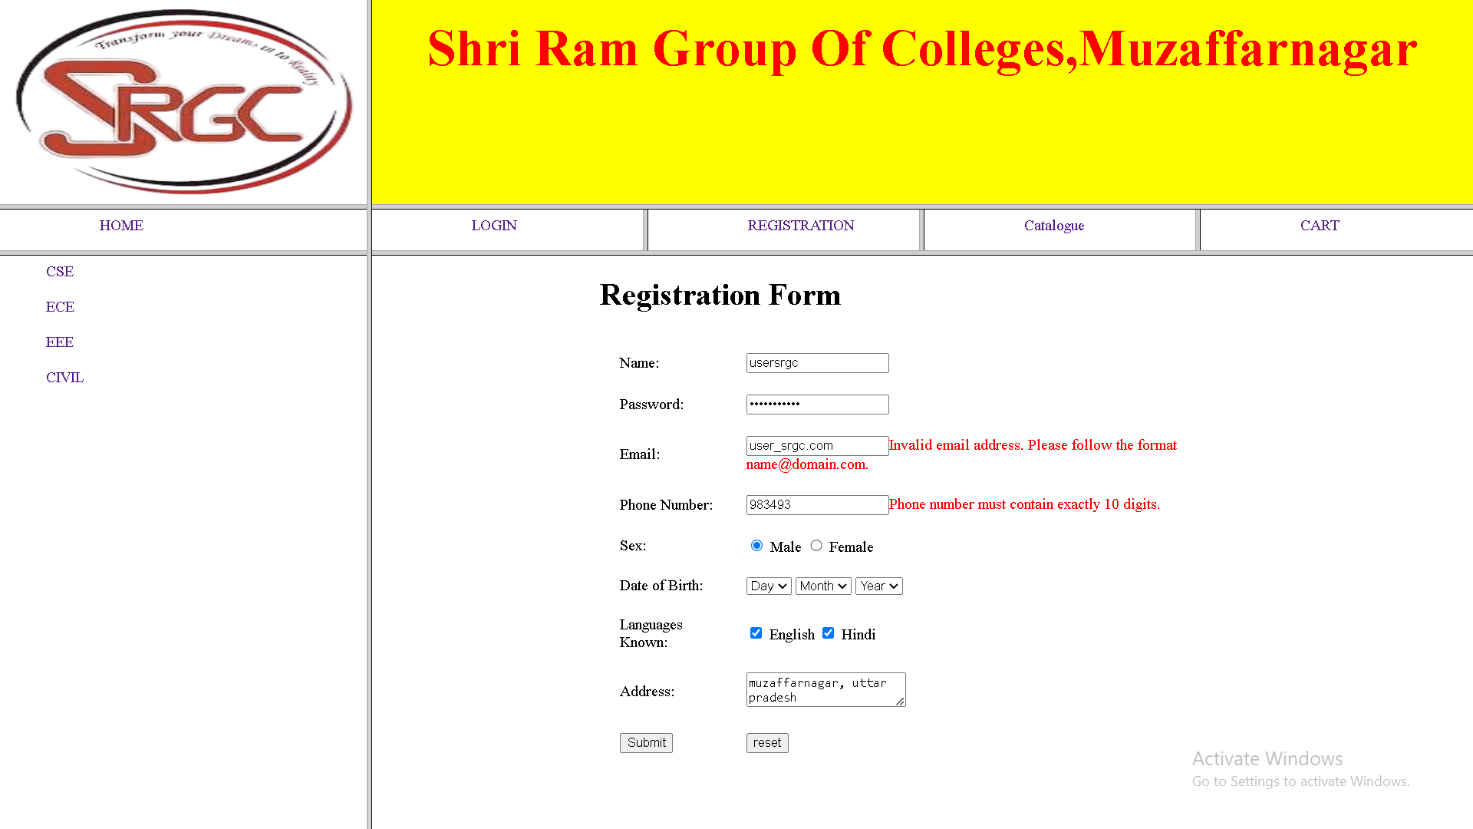

**Experiment-8**

**CSS:** Design a web page using **CSS(C**ascading **S**tyle **S**heets**)** which includes the following:

1. Use different font, styles: In the style definition you define how each selector should work(font, color etc.). Then, in the body of your pages, you refer to these selectors to activate the styles.
2. Set a background image for both the page and single elements on the page.

**Code:**

**=>example.html<=**

<!DOCTYPE html>

<html lang="en">

<head>

    <meta charset="UTF-8">

    <meta name="viewport" content="width=device-width, initial-scale=1.0">

    <title>Styled Web Page</title>

    <style>

            body {

            font-family: 'Arial, sans-serif';

            color: #333;

            margin: 0;

            padding: 0;

            background-size: cover;

            background-repeat: no-repeat;

            background-attachment: fixed;

        }

            header {

            text-align: center;

            padding: 20px;

            background-color: rgba(255, 255, 255, 0.8);

            font-family: 'Georgia, serif';

        }

            main {

            padding: 20px;

        }

        .content-box {

            margin: 20px auto;

            padding: 20px;

            max-width: 600px;

            background-color: rgba(255, 255, 255, 0.9);

            background-image: url('section-background.jpg');

            background-repeat: no-repeat;

            background-size: cover;

            border-radius: 10px;

            box-shadow: 0 4px 8px rgba(0, 0, 0, 0.1);

            font-family: 'Verdana, sans-serif';

        }

            footer {

            text-align: center;

            padding: 10px;

            background-color: rgba(0, 0, 0, 0.8);

            color: white;

            font-size: 14px;

        }

            a {

            color: #112211;

            text-decoration: none;

        }

        a:hover {

            color: #0056b3;

            background-color: #0056b3;

        }

    </style>

</head>

<body>

    <header>

        <h1>Welcome to My Stylish Web Page</h1>

    </header>

    <main>

        <a href="https://github.com/VanshSharma5/">

            <section class="content-box">

                <h2>About Us</h2>

                <p>This is a demonstration of CSS styling. You can use different fonts, colors, and background images to enhance your webpage.</p>

            </section>

        </a>

        <a href="index.html">

            <section class="content-box">

                <h2>Services</h2>

                <p>We provide high-quality web design and development services to help you build amazing websites.</p>

            </section>

        </a>

    </main>

    <footer>

        <p>&copy; 2025 My Stylish Web Page</p>

    </footer>

</body>

</html>

**Preview{Experiment-8}:**

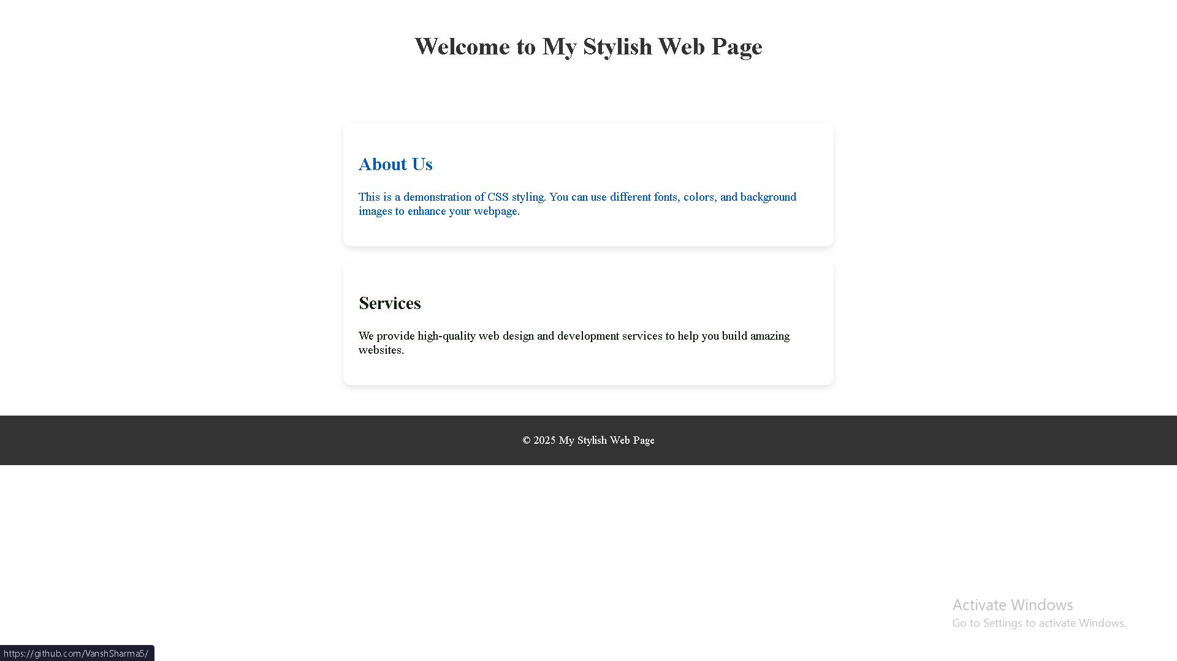

**Experiment-9**

**CSS:**

1. Control the repetition of the image with the background-repeat property.
2. Define styles for links as

A:link

A:visited

A:active

A:hover

**Code:**

**=>example1.html<=**

<!DOCTYPE html>

<html lang="en">

<head>

    <meta charset="UTF-8">

    <meta name="viewport" content="width=device-width, initial-scale=1.0">

    <title>CSS Styling</title>

    <link rel="stylesheet" href="example.css">

</head>

<body>

    <h1>Welcome to My Page</h1>

    <p>Here are some links:</p>

    <ul>

        <li><a href="https://t.me/OPEN_S0URSE">Visit Telegram</a></li>

        <li><a href="https://github.com/VanshSharma5/">Go to Google</a></li>

    </ul>

</body>

</html>

**=>example1.css<=**

body {

    background-image: url('your-image.jpg');

    background-repeat: no-repeat;

    background-size: cover;

}

a:link {

    color: blue;

    text-decoration: none;

}

a:visited {

    color: purple;

}

a:hover {

    color: red;

    text-decoration: underline;

}

a:active {

    color: green;

}

**Preview{Experiment-9}:**



**Experiment-10**

Consider a small topic of your choice on which you can develop static Webpages and try to implement all topics of html, CSS and Js within the topic.

Choose any one topic.

1. Your Own Portfolio
2. To-Do List
3. Survey Form
4. A Tribute Page
5. A Questionnaire

**Code:{Your Own Portfolio}**

**=>portfolio.html<=**

<!DOCTYPE html>

<html data-bs-theme="light" lang="en">

<head>

    <meta charset="utf-8">

    <meta name="viewport" content="width=device-width, initial-scale=1.0, shrink-to-fit=no">

    <title>Home - Brand</title>

    <link rel="stylesheet" href="assets/bootstrap/css/bootstrap.min.css">

    <link rel="stylesheet" href="https://fonts.googleapis.com/css?family=Source+Sans+Pro:300,400,700,300italic,400italic,700italic&amp;display=swap">

    <link rel="stylesheet" href="assets/fonts/font-awesome.min.css">

    <link rel="stylesheet" href="assets/fonts/line-awesome.min.css">

    <link rel="stylesheet" href="assets/fonts/simple-line-icons.min.css">

</head>

<body id="page-top"><a class="menu-toggle rounded" href="#"><i class="fa fa-bars"></i></a>

    <nav class="navbar navbar-expand" id="sidebar-wrapper">

        <div class="container"><button data-bs-toggle="collapse" class="navbar-toggler d-none" data-bs-target="#"></button>

            <div class="collapse navbar-collapse">

                <ul class="navbar-nav sidebar-nav" id="sidebar-nav">

                    <li class="nav-item sidebar-brand"><a class="nav-link active" href="#page-top">Brand</a></li>

                    <li class="nav-item sidebar-nav-item"><a class="nav-link" href="#page-top">Home</a></li>

                    <li class="nav-item sidebar-nav-item"><a class="nav-link" href="#about">About</a></li>

                    <li class="nav-item sidebar-nav-item"><a class="nav-link" href="#services">Services</a></li>

                    <li class="nav-item sidebar-nav-item"><a class="nav-link" href="#portfolio">Portfolio</a></li>

                </ul>

            </div>

        </div>

    </nav>

    <header class="d-flex masthead" style="background-image:url('assets/img/bg-masthead.jpg');">

        <div class="container my-auto text-center">

            <h1 class="mb-1">Vansh Sharma</h1>

            <h3 class="mb-5"><em>Python/C Developer</em></h3><a class="btn btn-primary btn-xl" role="button" href="https://github.com/VanshSharma5">Find Out More</a>

        </div>

    </header>

    <section id="services" class="content-section bg-primary text-white text-center">

        <div class="container">

            <div class="content-section-heading">

                <h3 class="text-secondary mb-0">Services</h3>

                <h2 class="mb-5">What I Offer</h2>

            </div>

            <div class="row">

                <div class="col-md-6 col-lg-3 mb-5 mb-lg-0"><span class="mx-auto service-icon rounded-circle mb-3"><i class="icon-screen-smartphone"></i></span>

                    <h4><strong>Responsive</strong></h4>

                    <p class="mb-0 text-faded">Looks great on any screen size!</p>

                </div>

                <div class="col-md-6 col-lg-3 mb-5 mb-lg-0"><span class="mx-auto service-icon rounded-circle mb-3"><i class="icon-pencil"></i></span>

                    <h4><strong>Redesigned</strong></h4>

                    <p class="mb-0 text-faded">Great in&nbsp; Designing Backend&nbsp;</p>

                </div>

                <div class="col-md-6 col-lg-3 mb-5 mb-lg-0"><span class="mx-auto service-icon rounded-circle mb-3"><i class="icon-like"></i></span>

                    <h4><strong>Favorited</strong></h4>

                    <p class="mb-0 text-faded"><span>Milions of users&nbsp;</span><i class="fa fa-heart"></i><span>&nbsp;us!</span></p>

                </div>

                <div class="col-md-6 col-lg-3 mb-5 mb-lg-0"><span class="mx-auto service-icon rounded-circle mb-3"><i class="icon-mustache"></i></span>

                    <h4><strong>Question</strong></h4>

                    <p class="mb-0 text-faded">I mustache you a question...</p>

                </div>

            </div>

        </div>

    </section>

    <section id="portfolio" class="content-section">

        <div class="container">

            <div class="content-section-heading text-center">

                <h3 class="text-secondary mb-0">Portfolio</h3>

                <h2 class="mb-5">Recent Projects</h2>

            </div>

            <div class="row g-0">

                <div class="col-lg-6"><a class="portfolio-item" href="https://github.com/VanshSharma5/WhatsApp_messege_sender">

                        <div class="caption">

                            <div class="caption-content">

                                <h2 class="text-primary-emphasis">WATSSUPMESSENGEER</h2>

                                <p class="text-primary-emphasis mb-0">A GUI application to send messages to an individual recurrively</p>

                            </div>

                        </div><img class="img-fluid" src="assets/img/Screenshot%202024-12-02%20194435.png">

                    </a></div>

                <div class="col-lg-6"><a class="portfolio-item" href="https://github.com/VanshSharma5/WhatsApp_messege_sender">

                        <div class="caption">

                            <div class="caption-content">

                                <h2 class="text-primary-emphasis">Goblin-Killer</h2>

                                <p class="text-primary-emphasis mb-0">Game with greate assence of Joy</p>

                            </div>

                        </div><img class="img-fluid" src="assets/img/Screenshot%202024-12-09%20131816.png">

                    </a></div>

                <div class="col-lg-6"><a class="portfolio-item" href="https://github.com/VanshSharma5/Student-Management-System-Mini-Project">

                        <div class="caption">

                            <div class="caption-content">

                                <h2 class="text-primary-emphasis">Student management SYSTEM&nbsp;</h2>

                                <p class="text-primary-emphasis mb-0">A fast and Reliable system Offers flexible Features&nbsp;</p>

                            </div>

                        </div><img class="img-fluid" src="assets/img/Screenshot%202024-12-09%20132055.png">

                    </a></div>

                <div class="col-lg-6"><a class="portfolio-item" href="https://github.com/VanshSharma5/C-_To_HTML">

                        <div class="caption">

                            <div class="caption-content">

                                <h2>c-to-html</h2>

                                <p class="mb-0">A set header files which provides flexiblity to generate Static HTML Pages</p>

                            </div>

                        </div><img class="img-fluid" src="assets/img/Screenshot%202024-12-09%20132503.png">

                    </a></div>

            </div>

        </div>

    </section>

    <footer class="text-bg-info footer text-center">

        <div class="container">

            <ul class="list-inline mb-5">

                <li class="list-inline-item">&nbsp;<a class="link-light social-link rounded-circle" href="https://t.me/OPEN_S0URSE"><svg xmlns="http://www.w3.org/2000/svg" width="1em" height="1em" fill="currentColor" viewBox="0 0 16 16" class="bi bi-telegram" style="font-size: 33px;">

                            <path d="M16 8A8 8 0 1 1 0 8a8 8 0 0 1 16 0M8.287 5.906c-.778.324-2.334.994-4.666 2.01-.378.15-.577.298-.595.442-.03.243.275.339.69.47l.175.055c.408.133.958.288 1.243.294.26.006.549-.1.868-.32 2.179-1.471 3.304-2.214 3.374-2.23.05-.012.12-.026.166.016.047.041.042.12.037.141-.03.129-1.227 1.241-1.846 1.817-.193.18-.33.307-.358.336a8.154 8.154 0 0 1-.188.186c-.38.366-.664.64.015 1.088.327.216.589.393.85.571.284.194.568.387.936.629.093.06.183.125.27.187.331.236.63.448.997.414.214-.02.435-.22.547-.82.265-1.417.786-4.486.906-5.751a1.426 1.426 0 0 0-.013-.315.337.337 0 0 0-.114-.217.526.526 0 0 0-.31-.093c-.3.005-.763.166-2.984 1.09z"></path>

                        </svg></a></li>

                <li class="list-inline-item">&nbsp;<a class="link-light social-link rounded-circle" href="https://huggingface.co/VanshSharma5"><svg xmlns="http://www.w3.org/2000/svg" width="1em" height="1em" fill="currentColor" viewBox="0 0 16 16" class="bi bi-emoji-smile" style="font-size: 29px;text-align: center;">

                            <path d="M8 15A7 7 0 1 1 8 1a7 7 0 0 1 0 14m0 1A8 8 0 1 0 8 0a8 8 0 0 0 0 16"></path>

                            <path d="M4.285 9.567a.5.5 0 0 1 .683.183A3.498 3.498 0 0 0 8 11.5a3.498 3.498 0 0 0 3.032-1.75.5.5 0 1 1 .866.5A4.498 4.498 0 0 1 8 12.5a4.498 4.498 0 0 1-3.898-2.25.5.5 0 0 1 .183-.683M7 6.5C7 7.328 6.552 8 6 8s-1-.672-1-1.5S5.448 5 6 5s1 .672 1 1.5m4 0c0 .828-.448 1.5-1 1.5s-1-.672-1-1.5S9.448 5 10 5s1 .672 1 1.5"></path>

                        </svg></a></li>

                <li class="list-inline-item">&nbsp;<a class="link-light social-link rounded-circle" href="https://github.com/VanshSharma5"><i class="la la-github" style="font-size: 33px;"></i></a></li>

            </ul>

            <p class="text-muted mb-0 small">Copyright &nbsp;© Brand 2024</p>

        </div><a class="scroll-to-top rounded" href="#page-top"><i class="fa fa-angle-up"></i></a>

    </footer>

    <script src="assets/bootstrap/js/bootstrap.min.js"></script>

    <script src="assets/js/stylish-portfolio.js"></script>

</body>

</html>

**Preview{Experiment-10}:**

